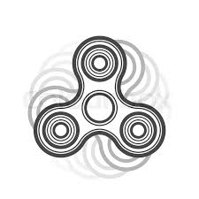
Name:______________________________
Fidget Spinner Project Rubric
INTRO:
Incredible Toys Inc. has had a mass amount of excess plastic left over from creating their action figures. They do not want to waste their excess material, so they decided to hire you to create a functional toy from their excess material. With the increasing popularity of Fidget Spinners, they want you to create a new version consisting of 4 bearings. They expect you to design and 3-D print a prototype to present during the next research and development company meeting. The meeting will take place a week and a half from today at 9am in conference room C017.
CONSTRAINTS:
Autodesk Inventor Drawings:
- Title Page: Text & Isometric View ____/2pts
- Dimensions: Heights, Widths, Depths, Diameters, Radiuses ____/16pts
  - 1 point per dimension
- Correct Dimension Orientations (4 parts) ____/12pts
  - 1 point per correct dimension orientation (height, widths, depths, etc.)
- Exploded View ____/5pts
  - Clean and precise ballooned parts
  - Ballooned parts must correlate with parts list
- Parts list ____/4pts
  - 1 point per part number
  - 1 point for the entire amount of parts column
Functioning 3-D printed Fidget Spinner:
- Needs to make at least 5 consistent revolutions in one spin ____/5pts
- Ball bearings flushed to body and pressed in using arbor press ____/5pts
  - 1 point per flushed bearing
  - 1 point for all of the beings being arbor pressed
- Needs to be able to spin in only one hand ____/1pt

Total______/50pts

